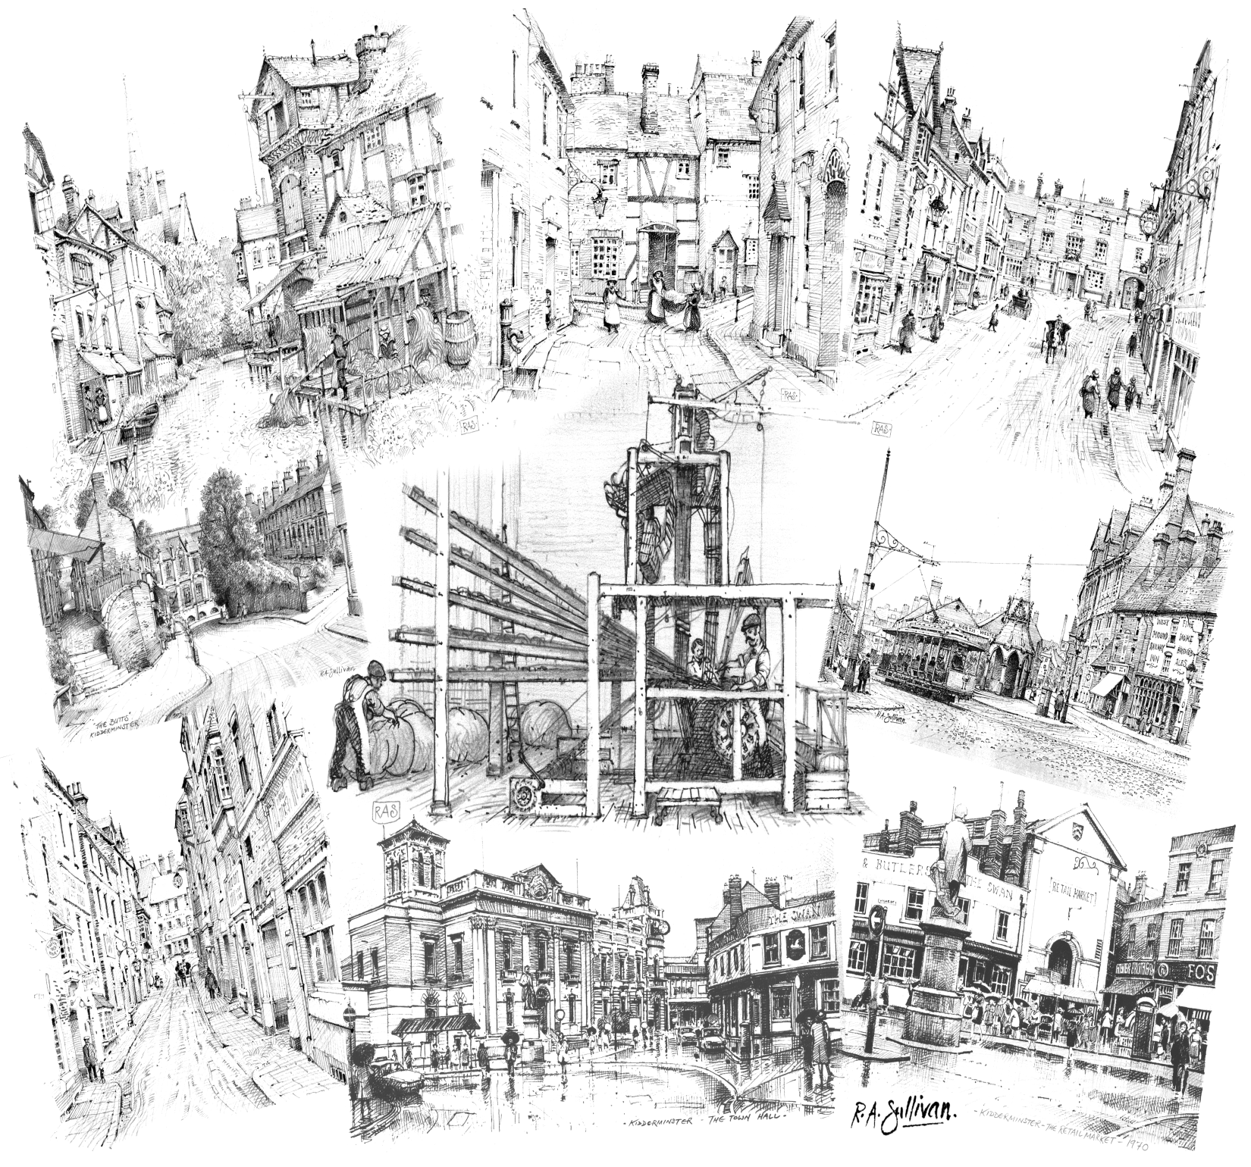

Friends of the
Sketches from the Friends 2003 Christmas Card Rev Dec 2021
Museum of Carpet

Kidderminster

INFORMATION
and

MEMBERSHIP
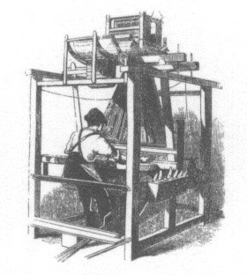

Preserving past & present
for the future

For further information

Friends of the Museum of Carpet
Museum of Carpet
Stour Vale Mill, Green Street
Kidderminster DY10 1AZ

Tel: 01562 69028
Email: friends@museumofcarpet.org.uk
www.museumofcarpet.org

The Museum of Carpet
The Carpet Museum Trust was founded in 1981 with a vision to create a museum in Kidderminster for the carpet industry.
A suitable site for a new museum was hard to find and with the economic difficulties faced by the local carpet industry in the 1990s, progress was delayed.
However, the vision of a permanent home for a Carpet Museum never wavered and, when the Trust was revived in 1997, the project gained new impetus.
The "Friends" organisation was formed in 2000.
In 2006, Wm Morrison Supermarkets plc. acquired the former Woodward Grosvenor factory and offered the Grade II listed Stour Vale Mill in Green Street to the Carpet Museum Trust. By September 2010 £1.97 million funding was secured from the Heritage Lottery Fund.
Work began on the site in August 2011 and the Museum of Carpet opened in October 2012.
About the 'Friends'
* We work with the Museum of Carpet in Kidderminster.
* Members' subscriptions help fund the Museum’s work.
* We run a public fundraising lottery, the "Carpet Sweep".
* We offer a range of membership categories with
museum entry concessions.
* We have an informative and colourful Newsletter
containing historical information, carpet industry news
and details of activities and opportunities.
* We organise our own events and parties.
* Many members also become volunteers and help with
a variety of projects connected with running the
museum and preserving the carpet industrial heritage.
This can be working in the shop or galleries, giving
demonstrations, cataloguing or doing research in our
archives, helping with school and other group visits,
fundraising events, publicity – and other activities.
So why not join us and become a
Friend of the Museum of Carpet

There are 3 ways to pay.

MEMBER’S DETAILS PLEASE PRINT

Name(s) Mr/Mrs/Miss ..………………………………………...…………………………..
Address …………………………………………………………................................……
……………………………………………..……. Post Code …………………………..………
Telephone .……………………………………………………….............................……
Email .………….…………………………………………………………………………….……...
We will send your newsletter to this address unless you request otherwise
MEMBERSHIP CATEGORIES (Please TICK selections)
I/we wish to renew my/our membership
I/we wish to join the friends
Single membership £12.50 per year
Joint membership £20.00 per year
Family with children £20.00 per year
Single Life membership £125.00
Joint Life membership £175.00
I/we would like to make a donation to the ‘Friends’ £
Total £
METHOD OF PAYMENT (Please TICK selection)
I enclose a cheque for £...............................
Payable to “Friends of the Museum of Carpet” £££

I will set up an Annual Standing Order

To “Friends of the Museum of Carpet”

General Data Protection Act and Privacy Policy:

The Society’s membership records are kept on computer for our internal use ONLY. Members’ details will not be made available to any other organisation. Please refer to the Society’s Privacy Policy on our website.

Please tick the box below to confirm that you agree to the Society holding the information on this form in order to contact you.

1 Pay by Cheque
If you wish to pay by cheque, please send this completed part of the form above (together with a S.A.E.) to

The Friends Membership Secretary
Museum of Carpet
Stour Vale Mill, Green Street
Kidderminster DY10 1AZ
2 Pay by Standing Order
Please fill in this Bank Standing Order form and take it to the local branch of your bank or, if you use internet banking, set up a Standing Order online.
YOUR BANK DETAILS PLEASE PRINT

Bank Name ………………………………………………………………………………………..
Branch Name ……………………………………………………………………………………..
Branch Address ………………………………………………………………………………….
Name of account to be debited Account Number
………………………………………………………... ………………….……………………........
Account Holder …………………………………………….……………………………………
Address …………………………………………………...………………………………………..
……………………………………………..……. Post Code …………………………..………
YOUR INSTRUCTIONS (Please PRINT)
Please pay the sum of … £
Amount in words ……………………………………………….………………………………
To : National Westminster Bank Plc
Kidderminster Branch
For the credit of the Friends of the Museum of Carpet
Account Number : 35958537 Sort code 60-12-12
On ………..……….... (day) ……………..…….. (month) …………..………. (year)
and thereafter on the first day of April annually, until you receive further notice in writing.
Signature 1 ……………………………………….……………..…………………………………
Signature 2 ……………………………………….……………..…………………………………
(For joint accounts where both signatures are required)
3 Pay by Internet Transfer (BACS)
Or alternatively, if you wish to pay directly by internet transfer you can do so using our account number and sort code as above but make sure we can identify you as the payee.

